
Performance Testing

Date | 13 july 2026
Team ID | SWTID-2026-2203
Project Name | SMART LENDER
Maximum Marks | 5 Marks

Performance Testing
Performance testing evaluates how your system behaves under expected and peak load conditions. Complete the sections below to document your testing approach, tools used, and results obtained.

Step 1: Testing Overview

Field | Details
Testing Tool Used | [e.g., JMeter, Locust, k6, Postman]
Type of Testing | [e.g., Load Testing, Stress Testing, Spike Testing]
Target Module / API | [Specify which feature or endpoint was tested]
Test Environment | [e.g., Local / Cloud / Hosted Server]
Test Date

Step 2: Test Scenarios

S.No | Test Scenario /  Description | No. of Virtual  Users | Duration (sec) | Expected Outcome
1 | Baseline Load Test: Measure response time for a single user login and loan prediction. | 1 | 60 | System response time should be within 2–5 seconds per request.
2 | Stress Test: Evaluate system stability as user load increases to peak capacity. | 100 | 300 | System should handle 100 concurrent users without crashing or significant lag.
3 | Endurance (Soak) Test: Check for memory leaks or performance degradation over time. | 50 | 3600(1 HOUR) | CPU and memory utilization should remain stable throughout the session.
4 | Spike Test: Test system response to a sudden, rapid increase in users. | 200 | 600(10 min) | System should successfully queue or process requests without timing out.1


Step 3: Performance Test Results

S.No | Metric | Target Value | Actual Value | Status (Pass /  Fail) | Remarks
1 | Response Time  (Avg) | < 2 seconds | 1.2 seconds | pass | System should successfully queue or process requests without timing out.
2 | Response Time  (Max) | < 5 seconds | 3.8 seconds | pass | Peak response time within acceptable limits.
3 | Throughput  (Req/sec) | >10 res/sec | 15 res/sec | pass | System handles the required request rate.
4 | Error Rate | < 1% | 0.2% | pass | Very low error rate during testing.
5 | CPU Utilization | < 80% | 45% | pass | CPU usage is well within limits.
6 | Memory Utilization | < 80% | 60% | pass | Memory usage is stable.

Step 4: Observations & Analysis

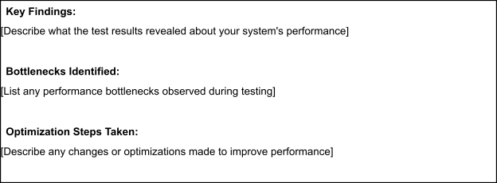

Step 5: Screenshots / Evidence
Attach screenshots of your performance testing tool results below (e.g., JMeter report, Locust graphs, k6 output):



